Nassau General Services is proud to present:
~A Workshop~
“OUR TWELVE CONCEPTS for WORLD SERVICE:”
AA’S Spiritual Principles of Recovery

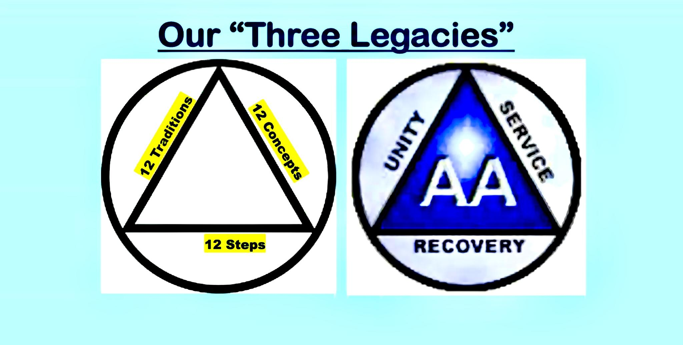
**** Suggest to have your service manual. It’s open for all A.A. members.
The workshop will be a Virtual Workshop. 7:30pm-9:00pm EST*****
922 8787 8377 Passcode 12345
Dates :
January 17 Concepts 1 & 2
March 21 Concepts 3 & 4
May 16 Concepts 5 & 6
July 18 Concepts 7 & 8
September 19 Concepts 9 & 10
November 21 Concepts 11 & 12

(1)

